- https://www.figma.com/proto/sEIA0JeXI1msGqJhybrdye/Free-Networking-icons--Community-?node-id=202-60&m=draw&scaling=min-zoom&content-scaling=fixed&page-id=0%3A180&starting-point-node-id=202%3A12&show-proto-sidebar=1&t=GG42kTP7qB90JyyQ-9
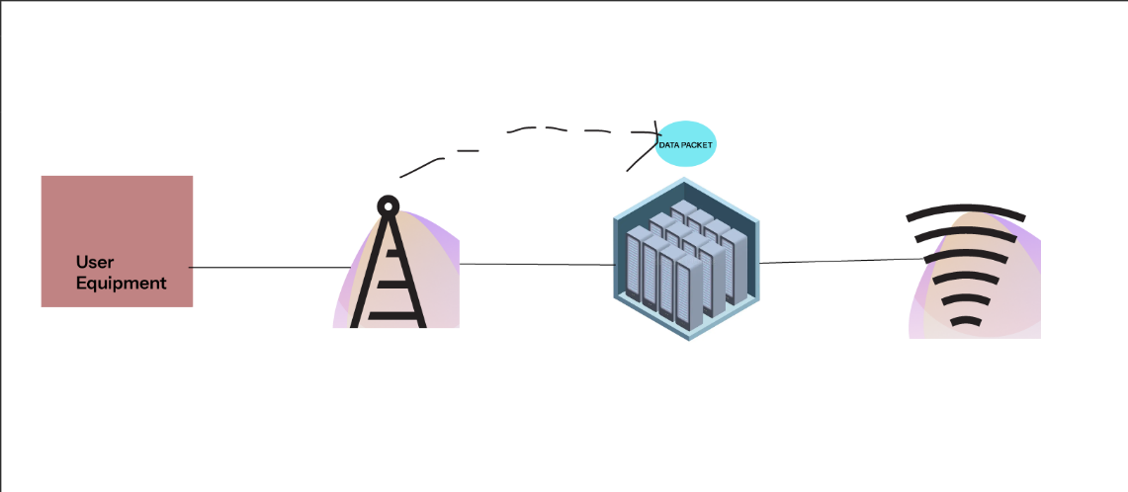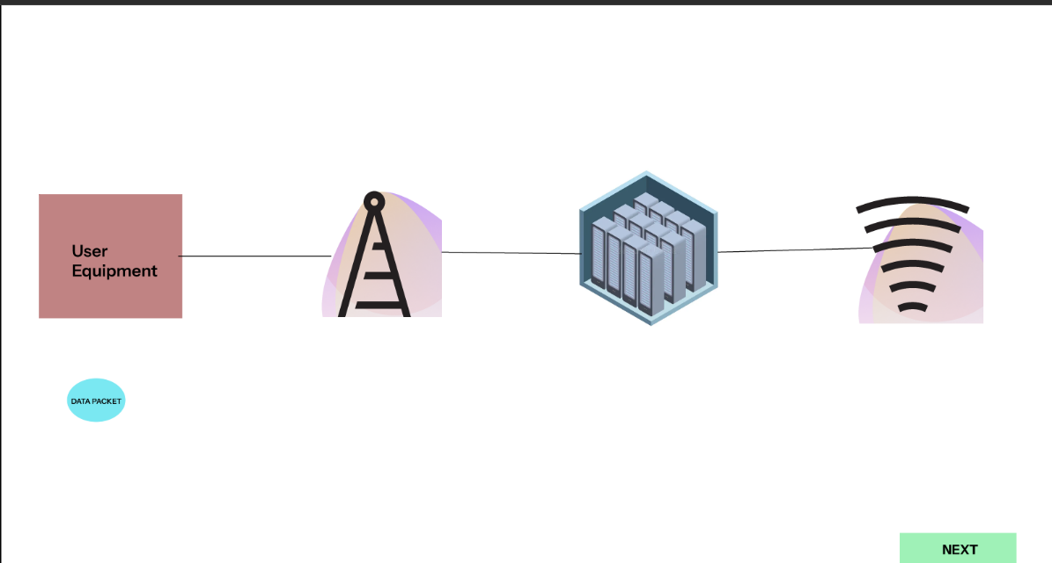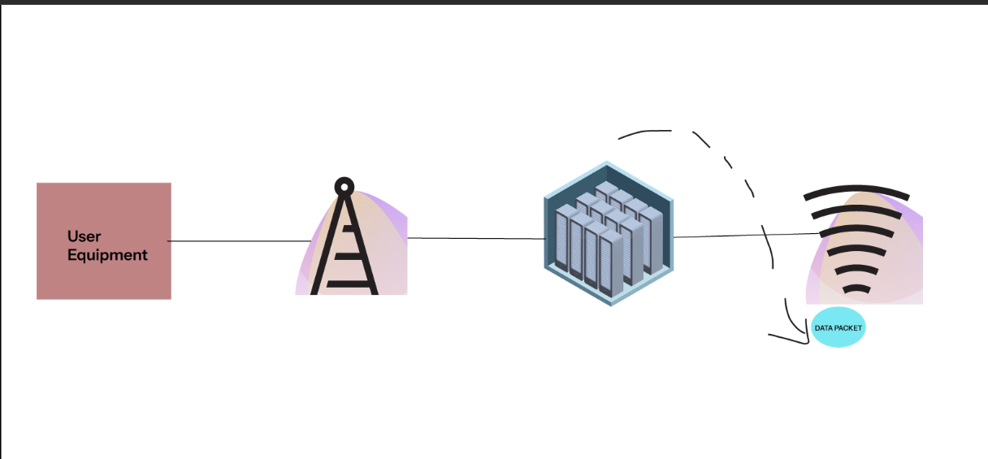

- https://www.figma.com/proto/t4YRJovVN3ChJf3KzPmy3L/Online-Bus-Seat-Booking-App--Community-?node-id=4-827&p=f&t=sYCy2qIIzK6SNcI3-1&scaling=min-zoom&content-scaling=fixed&page-id=0%3A1&starting-point-node-id=1%3A4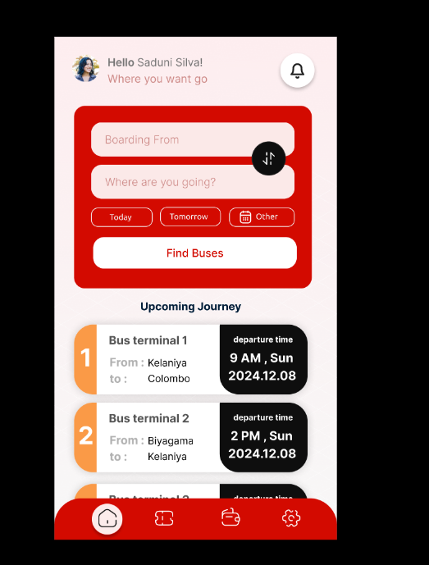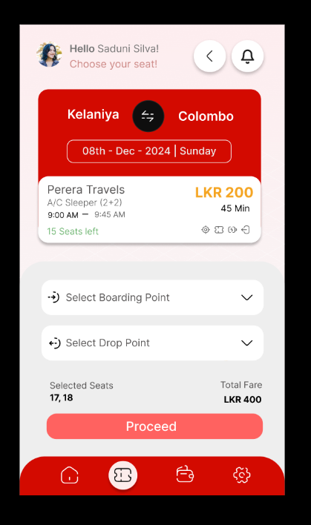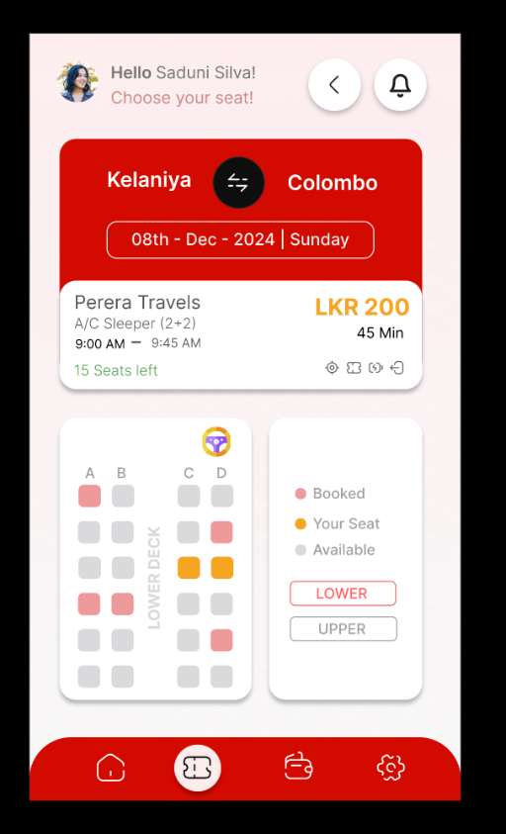
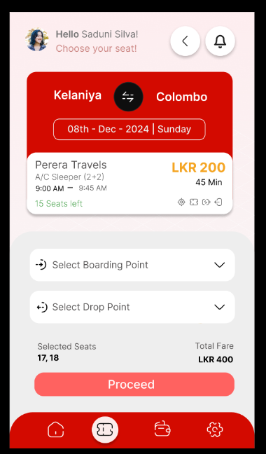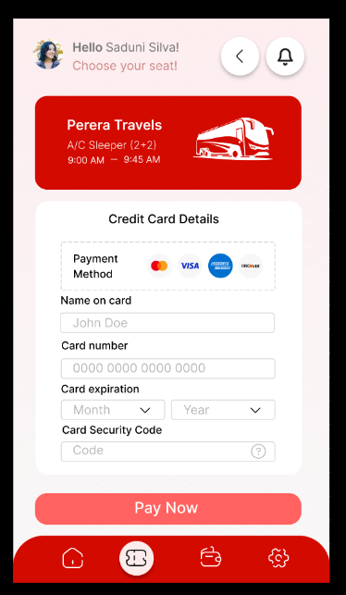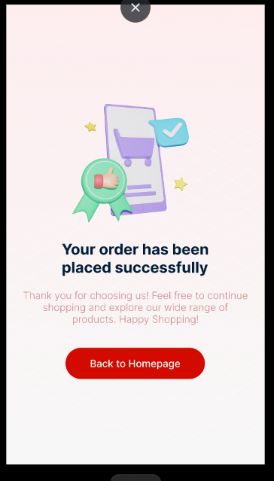
- https://www.figma.com/proto/fw6TOXchJcX7bF0plMUk9L/Untitled?t=2Noa2iaSsBplU2fc-0&scaling=min-zoom&content-scaling=fixed&page-id=0%3A1&node-id=1-2&starting-point-node-id=1%3A2

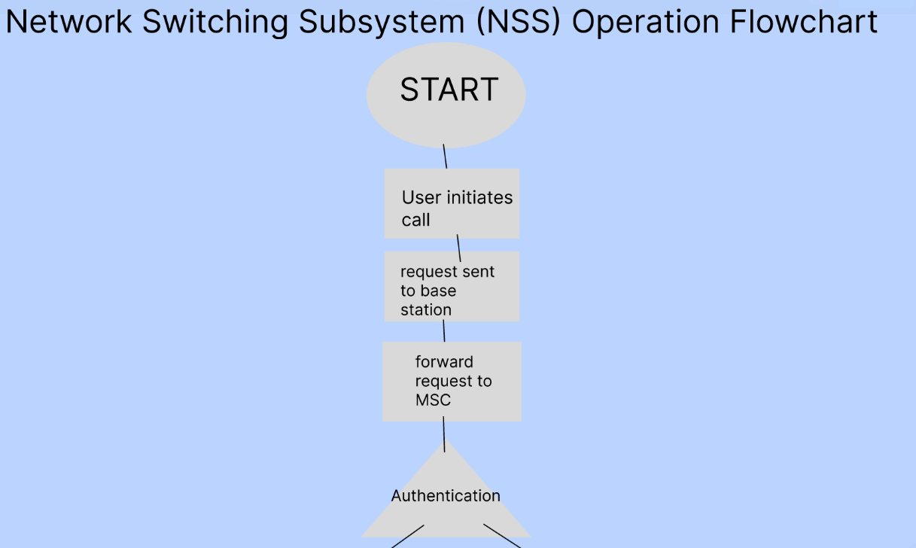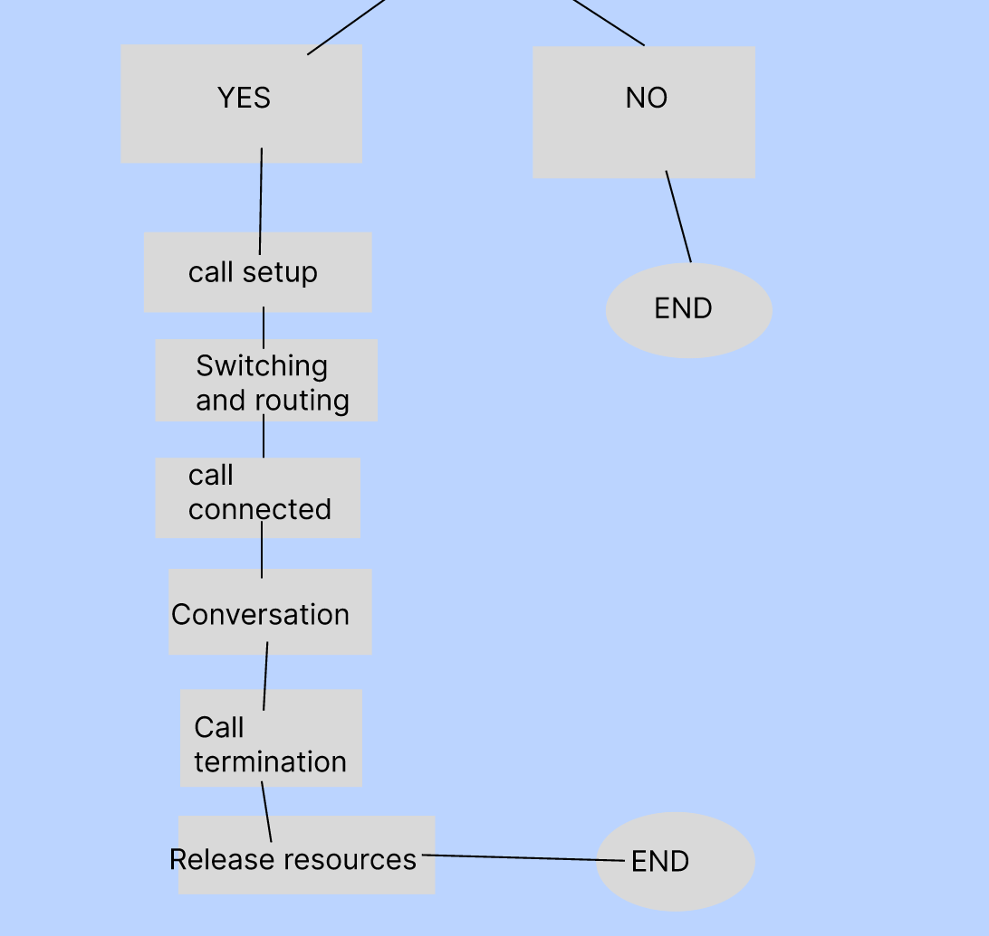

- figma.com/make/E2TNWX29L6oruEZ3cwue4f/Mobile-Network-Protocol-Stack-Visual?t=75kVvadkCzlvdXQA-20&fullscreen=1&code-node-id=0-6

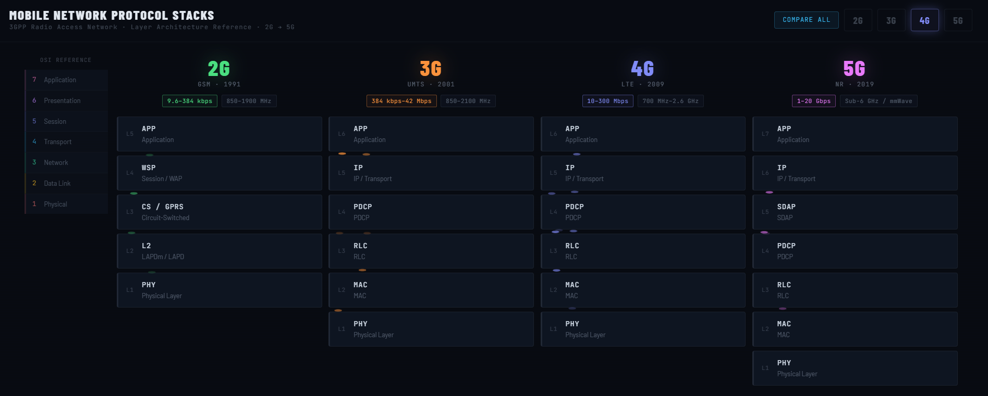

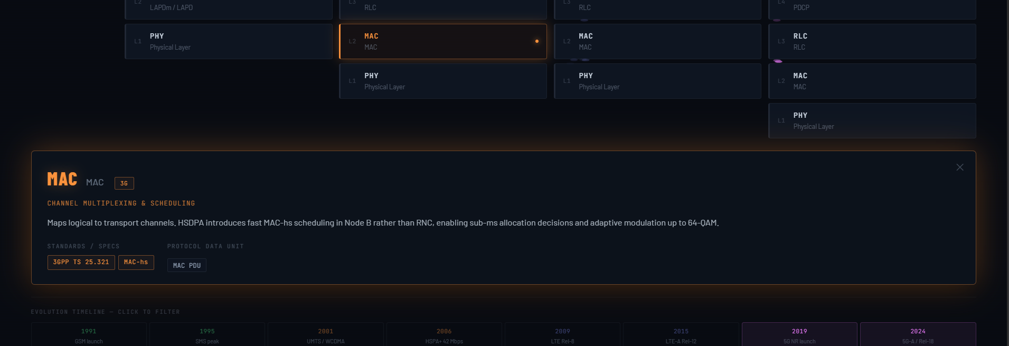

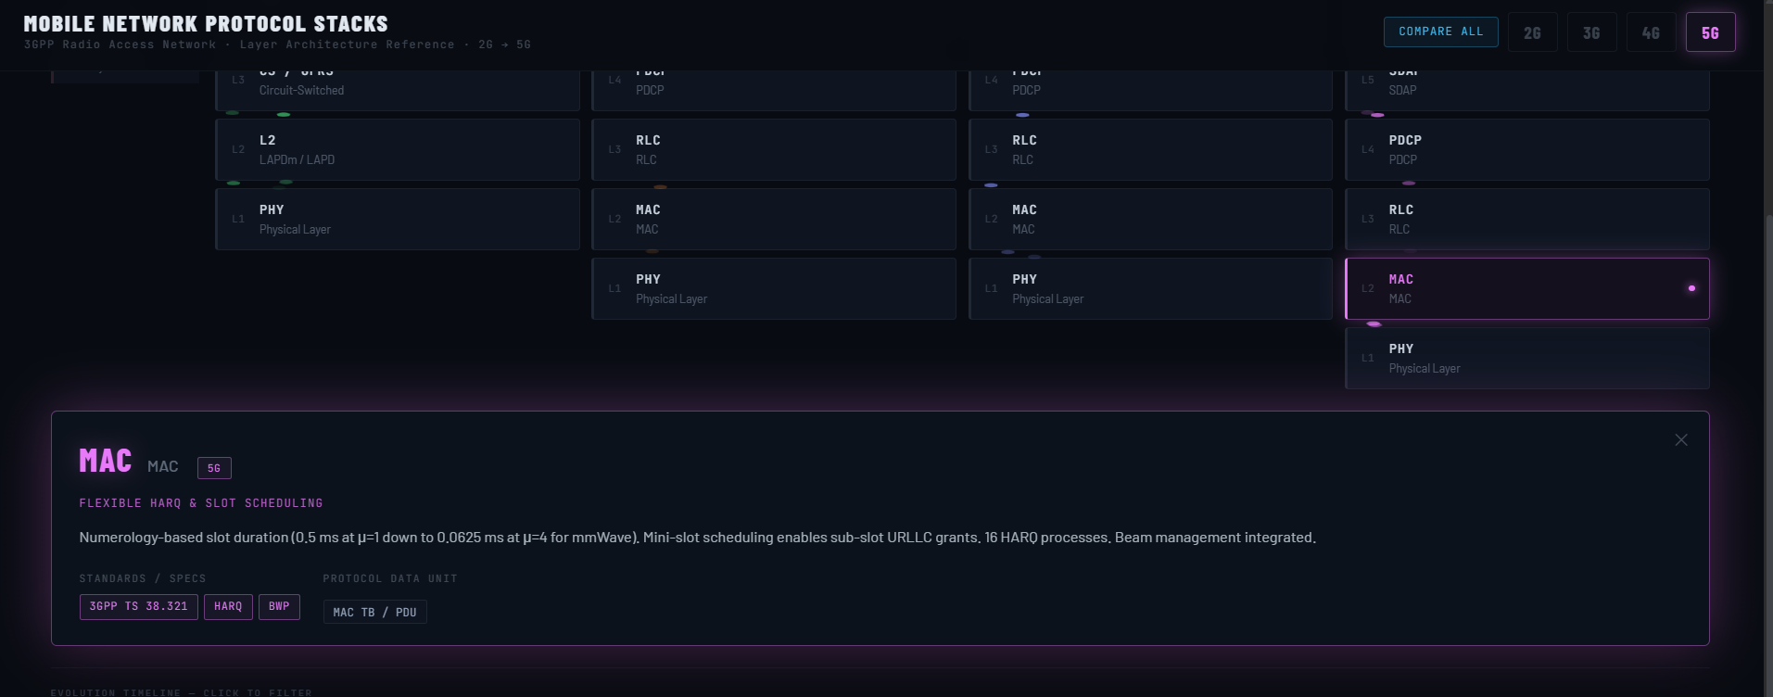

- https://www.figma.com/proto/NjMMWONWvHjLLm2YOwBXS2/%F0%9F%93%B2Wireframes-for-mobile-UI-design--Community-?node-id=76-703&p=f&t=7qedpxTi0NsMJYh6-0&scaling=min-zoom&content-scaling=fixed&page-id=35%3A0
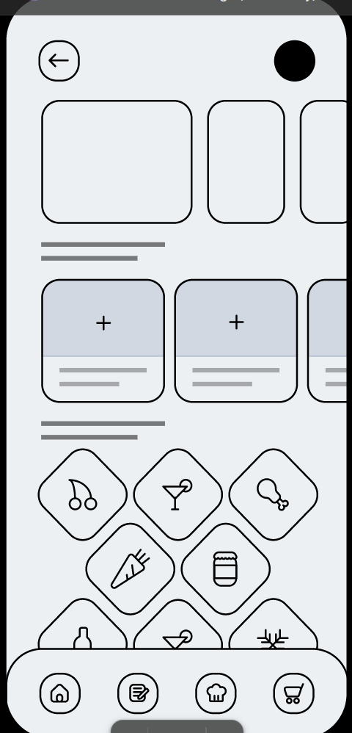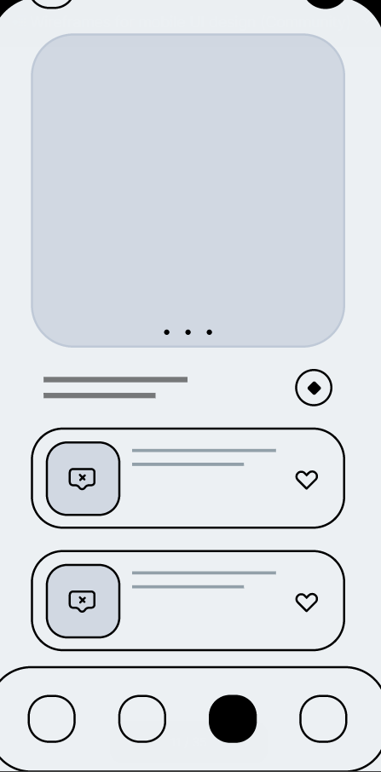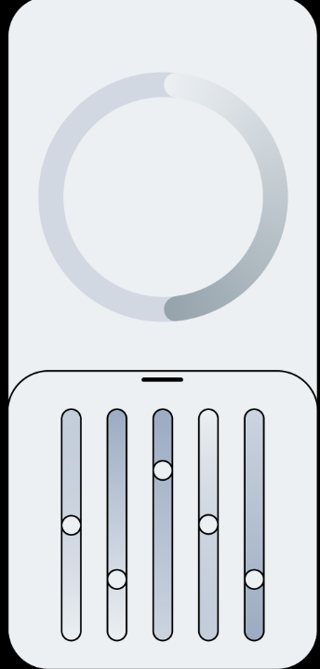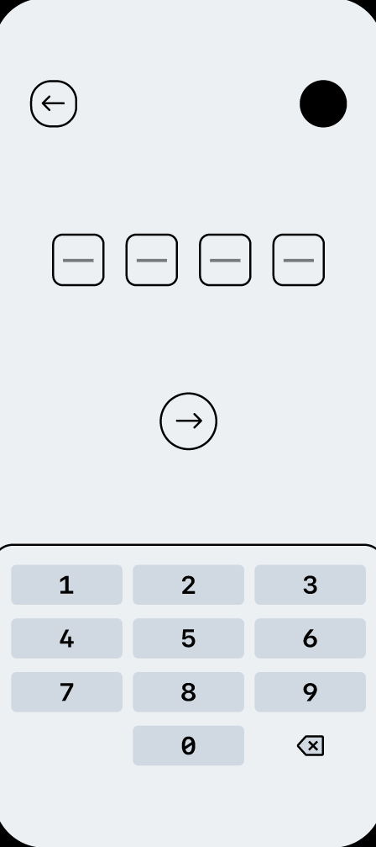
- https://www.figma.com/proto/r6wu9GUku9KJ4RbDA1pvLo/Untitled?node-id=1-2&p=f&t=2dldN5oYT1Al44Lx-0&scaling=scale-down&content-scaling=fixed&page-id=0%3A1&starting-point-node-id=1%3A2

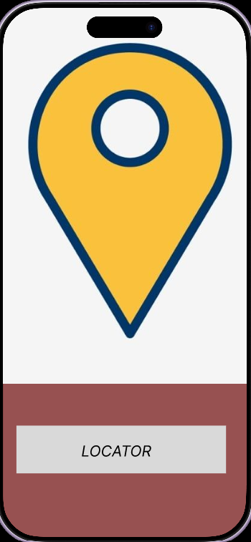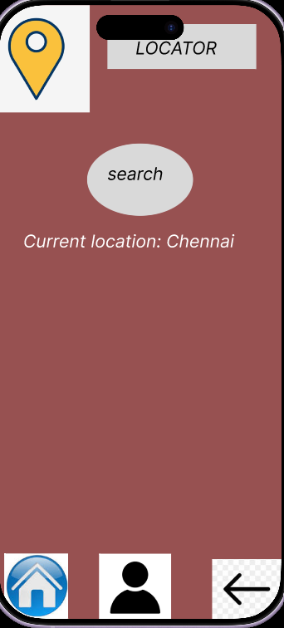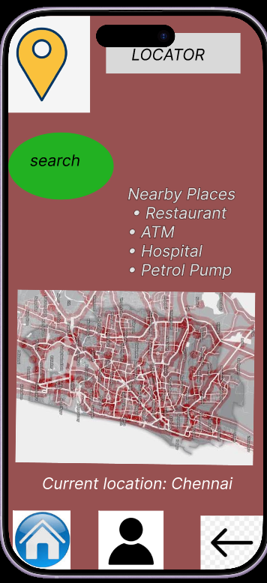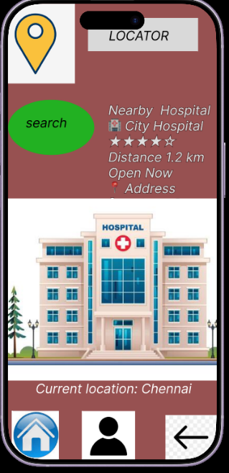
- https://www.figma.com/proto/anlSFmwv9DLuGFRw8HIrgK/Untitled?node-id=1-32&p=f&t=TikTMmuTj19vfZIY-0&scaling=min-zoom&content-scaling=fixed&page-id=0%3A1&starting-point-node-id=1%3A3

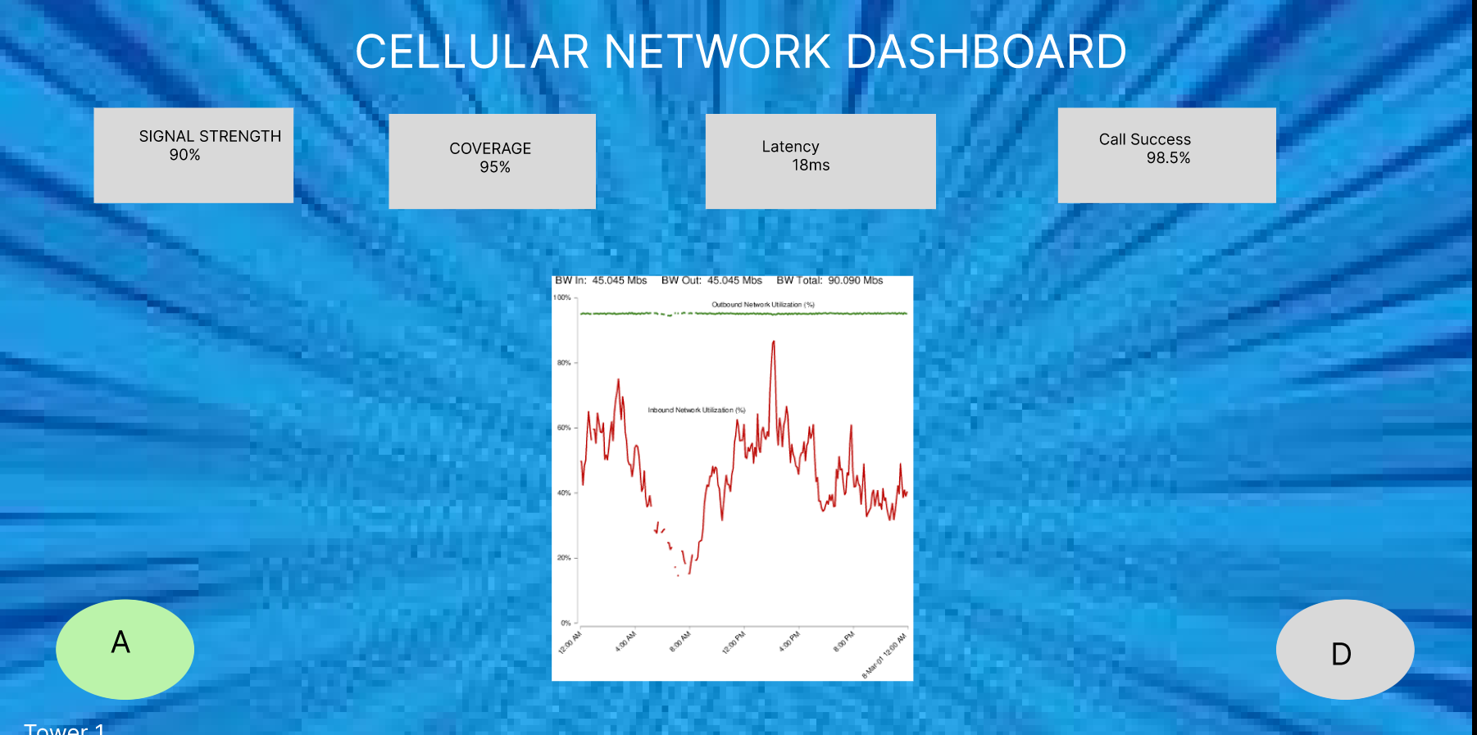
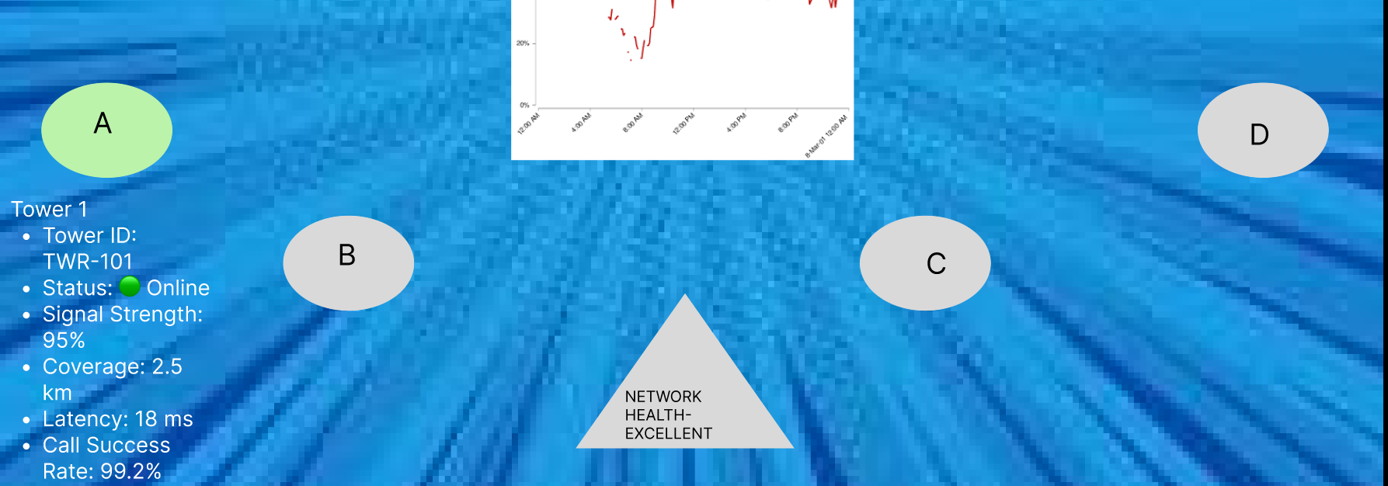
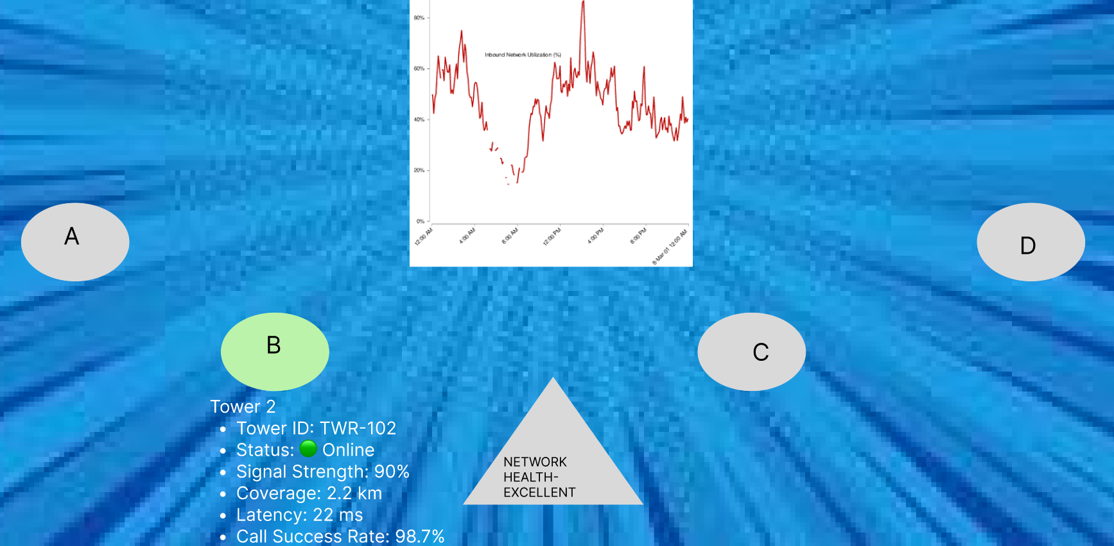
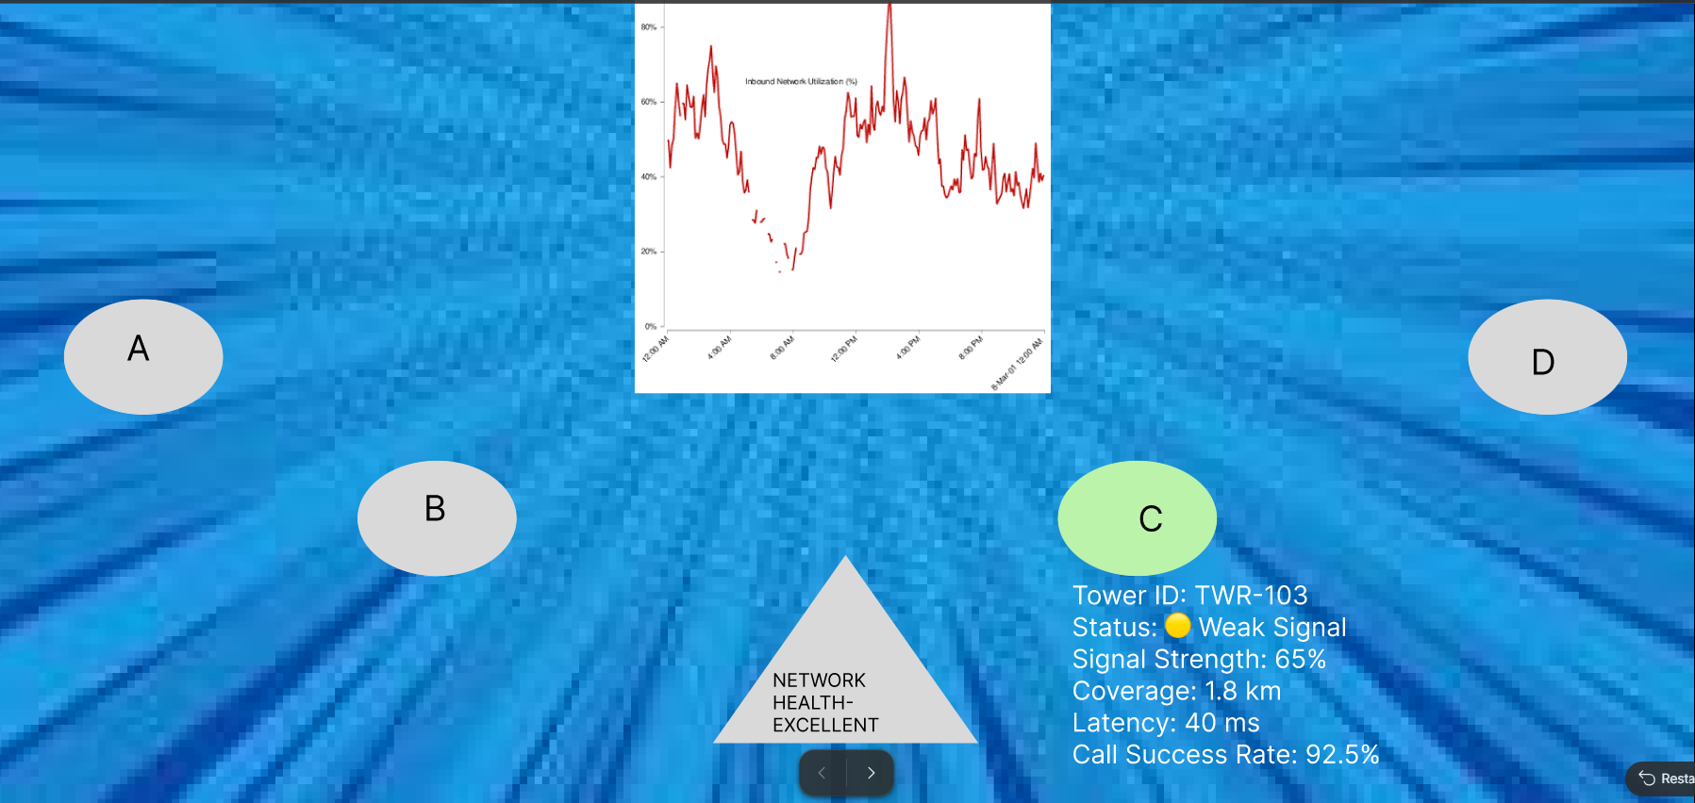

- https://www.figma.com/proto/oX5z3a7LdXtAyc8B1bmmvU/Untitled?node-id=1-2&p=f&t=RejCDFTOikF0hutT-0&scaling=min-zoom&content-scaling=fixed&page-id=0%3A1&starting-point-node-id=1%3A2
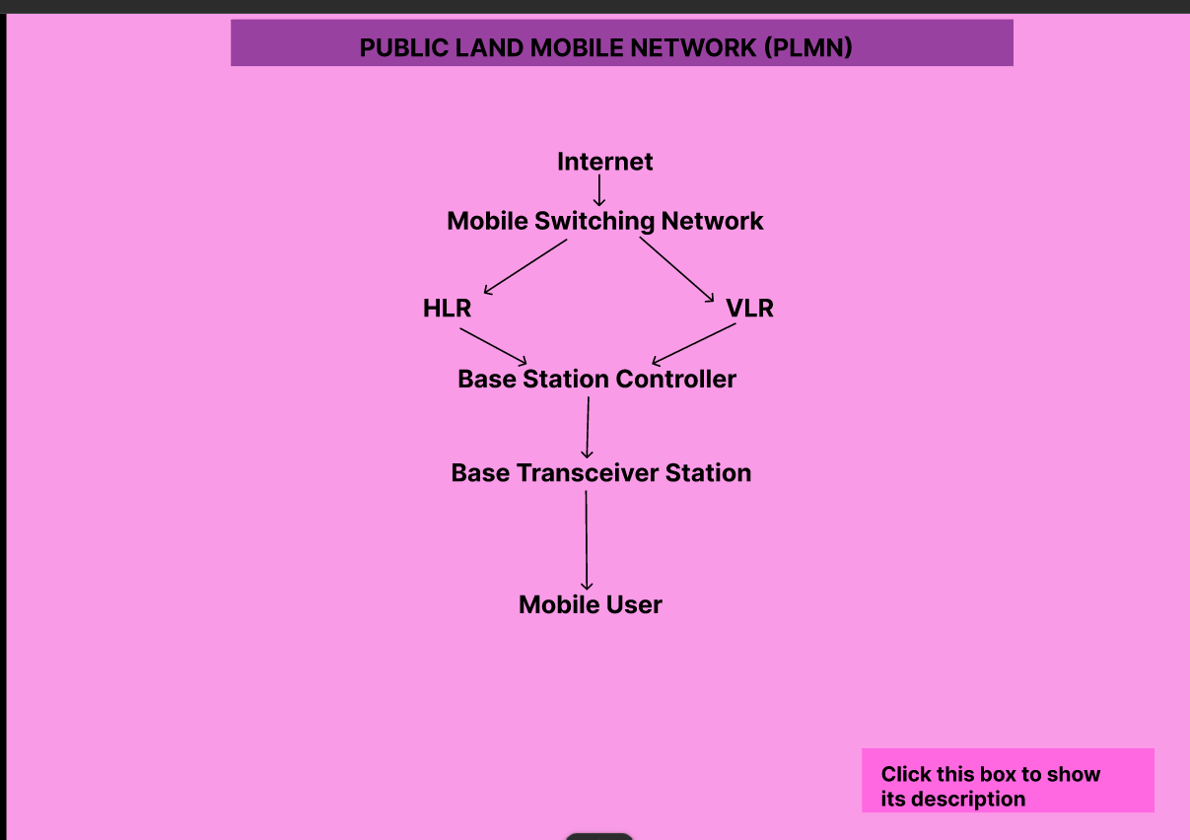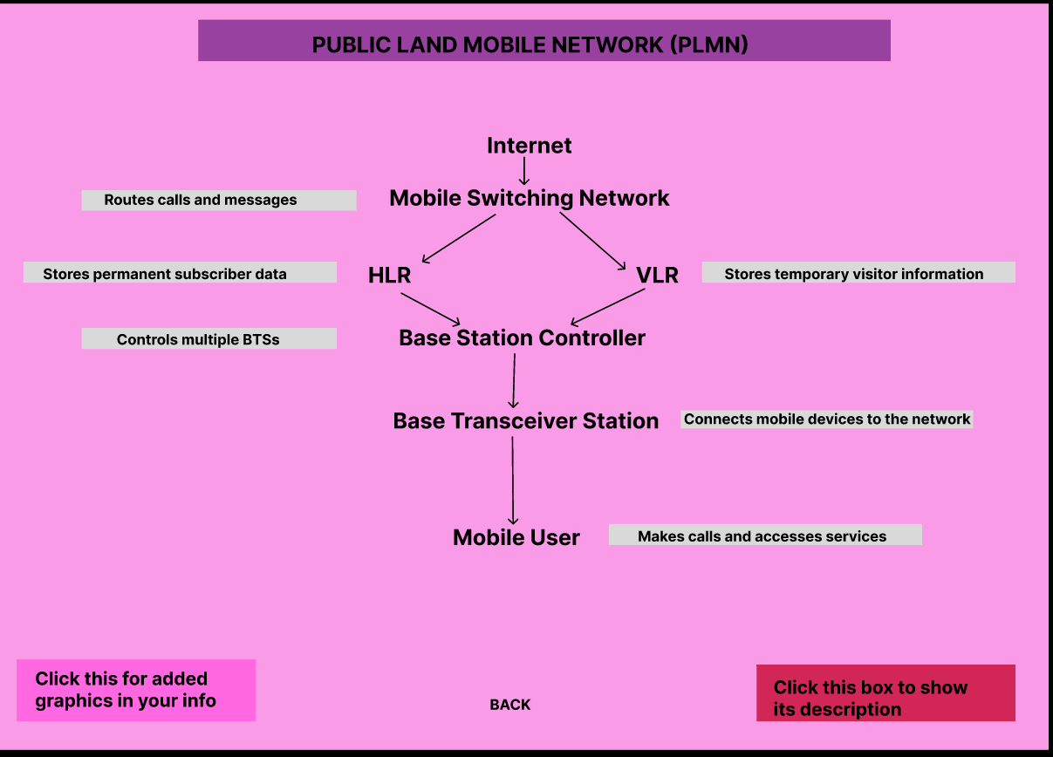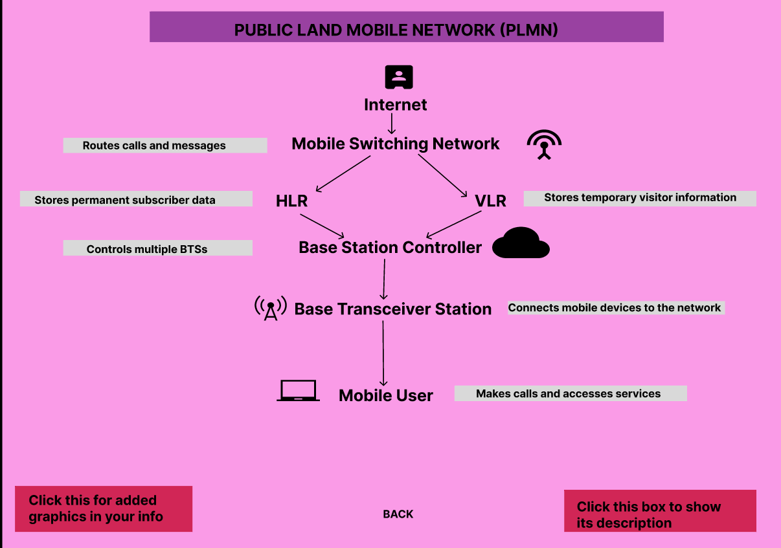
- https://www.figma.com/proto/nv9ANwMrysmaYiYHohZzjf/Untitled?node-id=1-2&p=f&t=RejCDFTOikF0hutT-0&scaling=scale-down&content-scaling=fixed&page-id=0%3A1&starting-point-node-id=1%3A2&show-proto-sidebar=1

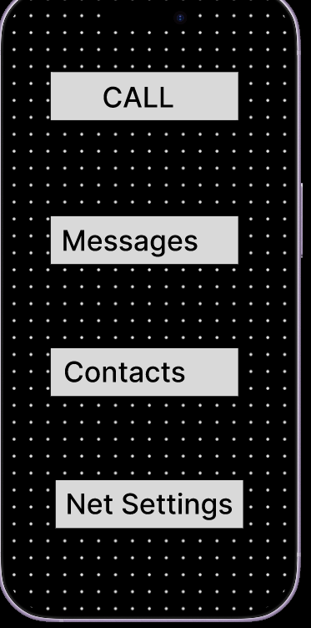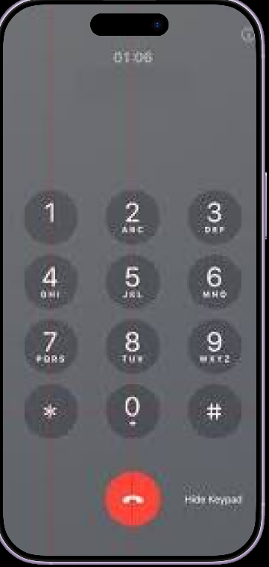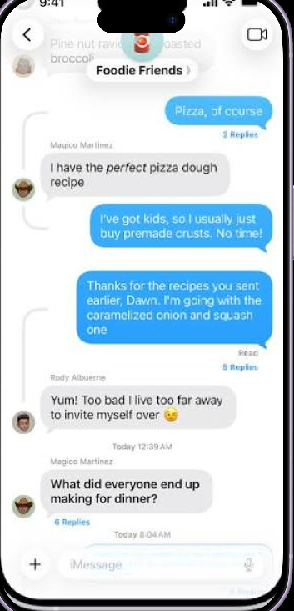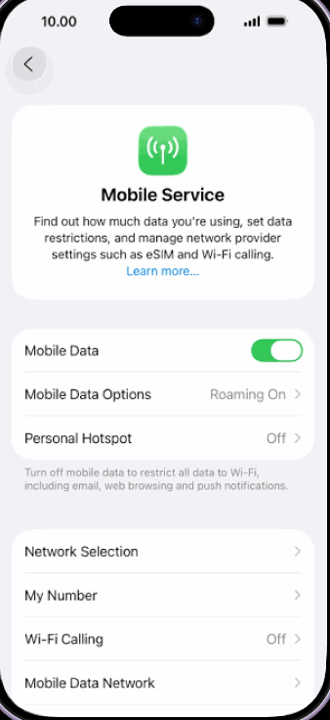

- https://www.figma.com/make/u3fEfgGxAWwApgAvv7digB/Educational-Infographic-Design?code-node-id=0-6&p=f&t=G68SUBweYtVLhCj0-0&fullscreen=1

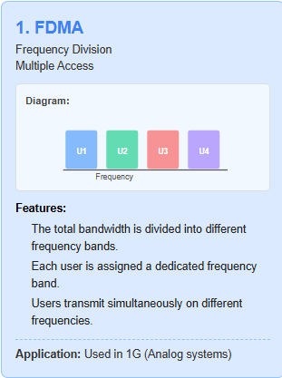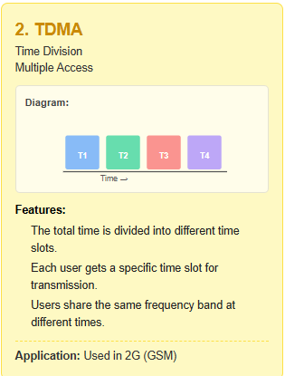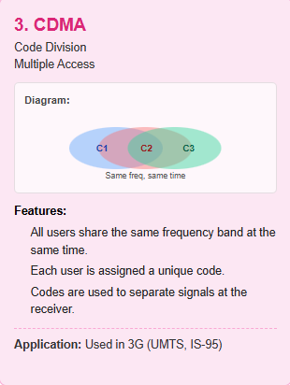
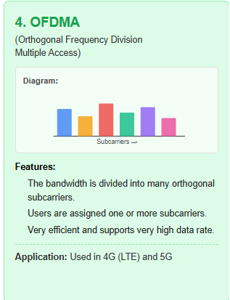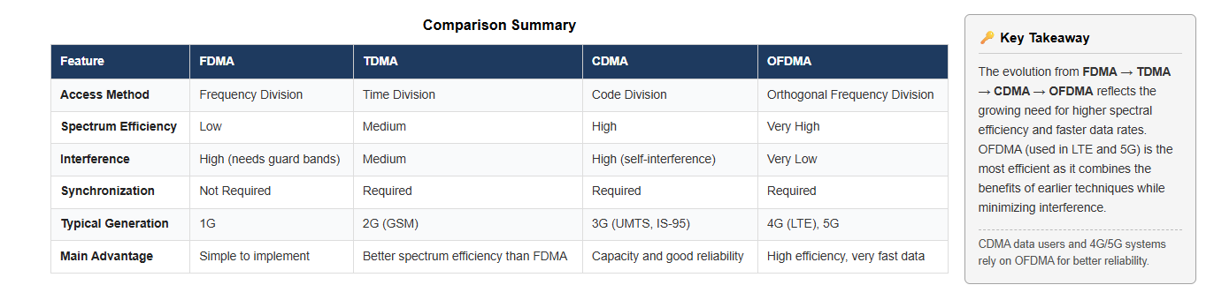

- https://www.figma.com/make/IfsjYFL0uT2ZhHFFyGTLGI/Security-flow-wireframe-prototype?code-node-id=0-6&p=f&t=56ATV4RRuid8xPwd-0&fullscreen=1

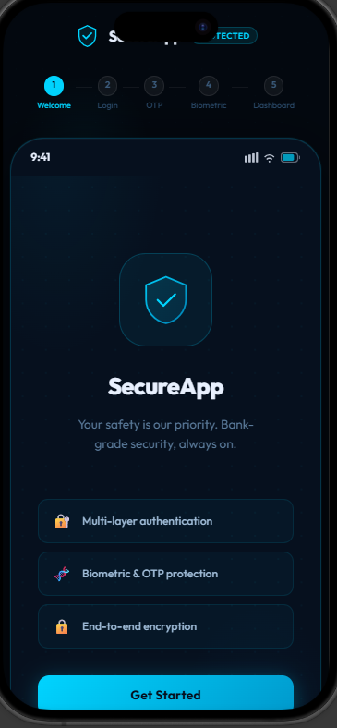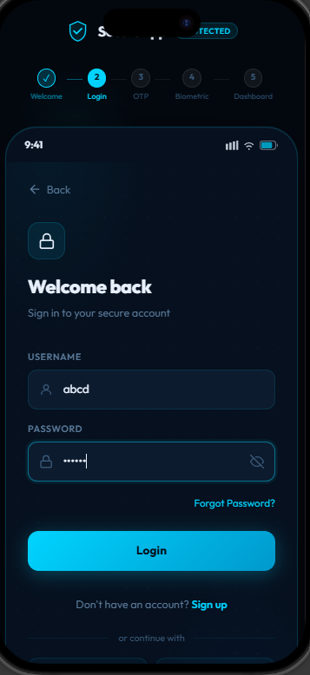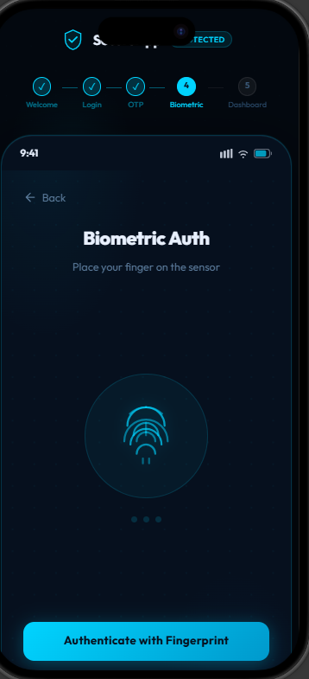
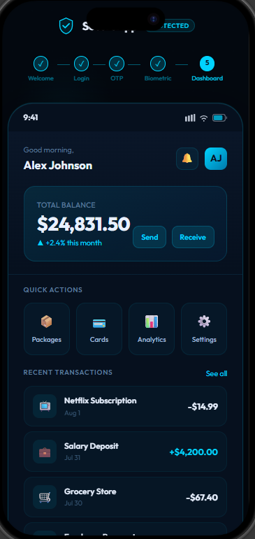

- https://www.figma.com/proto/GxTSVwOMZ2aD11M788pU5f/Untitled?node-id=1-2&p=f&t=RejCDFTOikF0hutT-0&scaling=min-zoom&content-scaling=fixed&page-id=0%3A1&starting-point-node-id=1%3A2

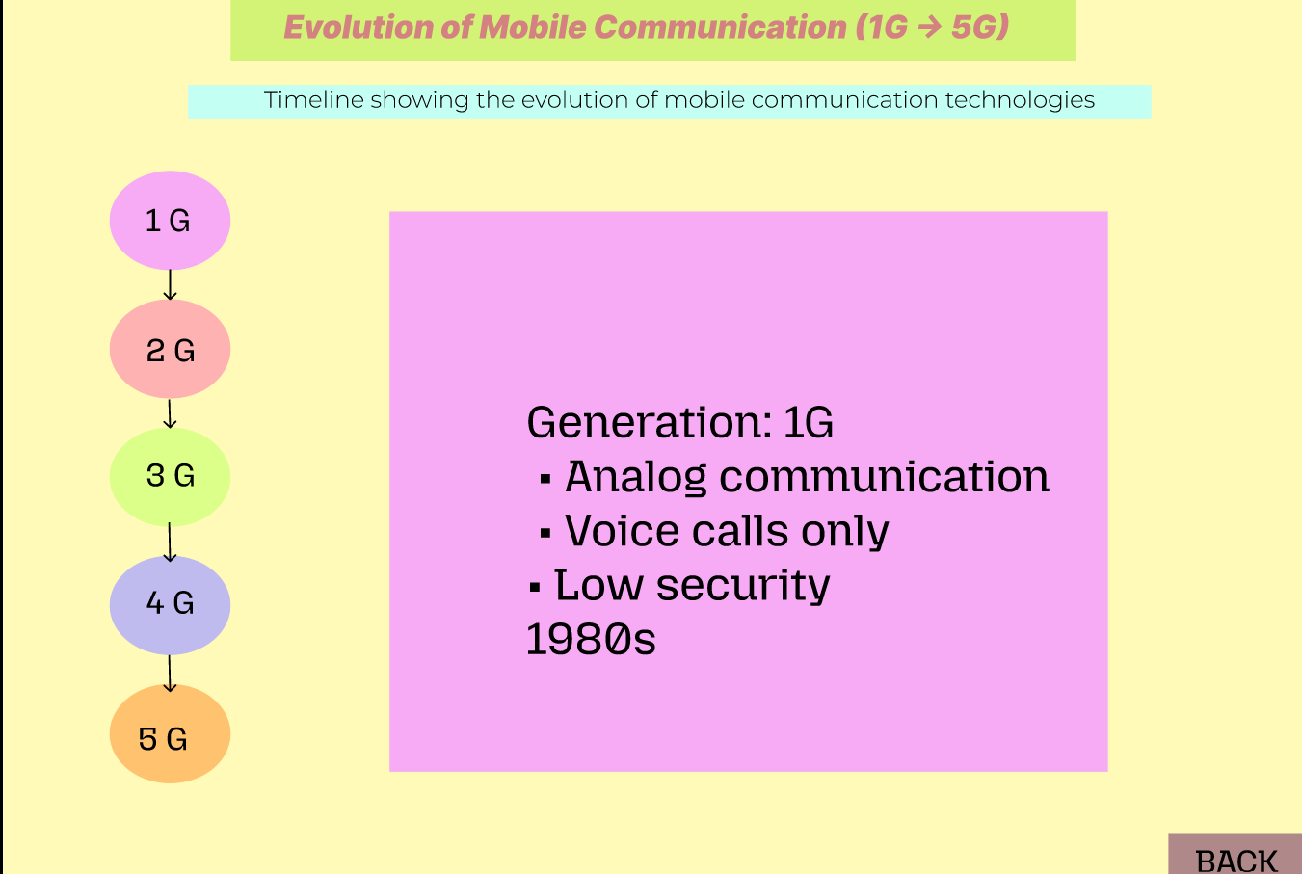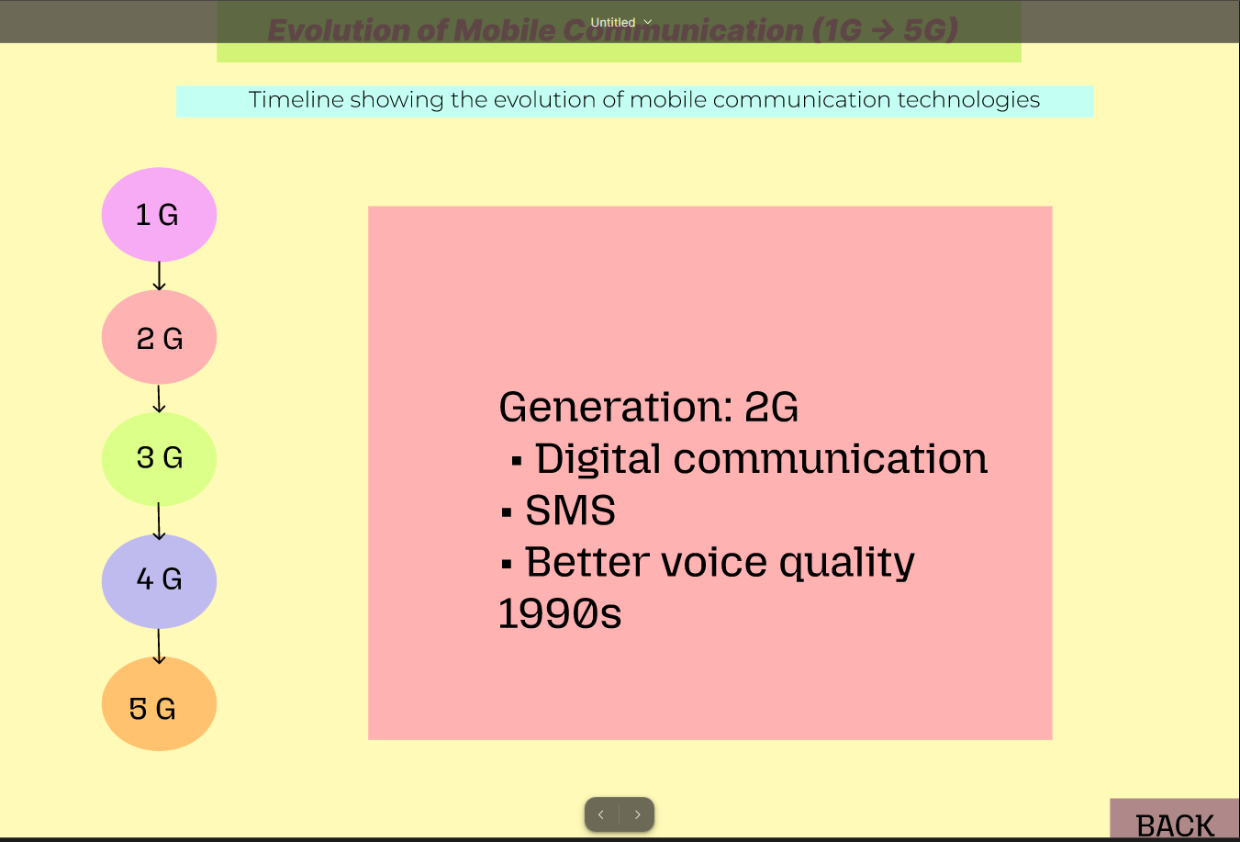
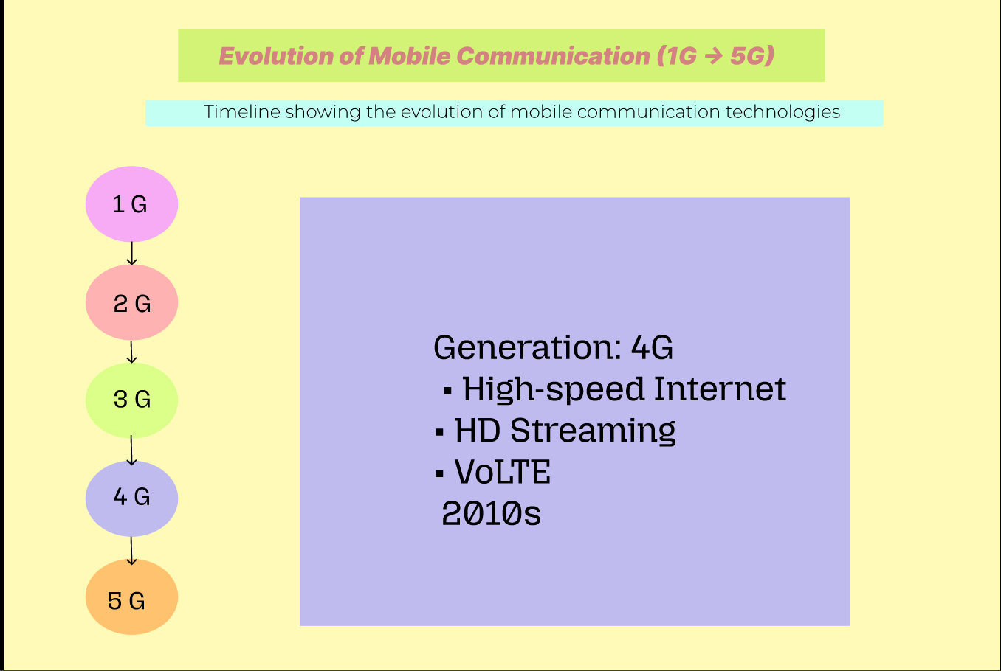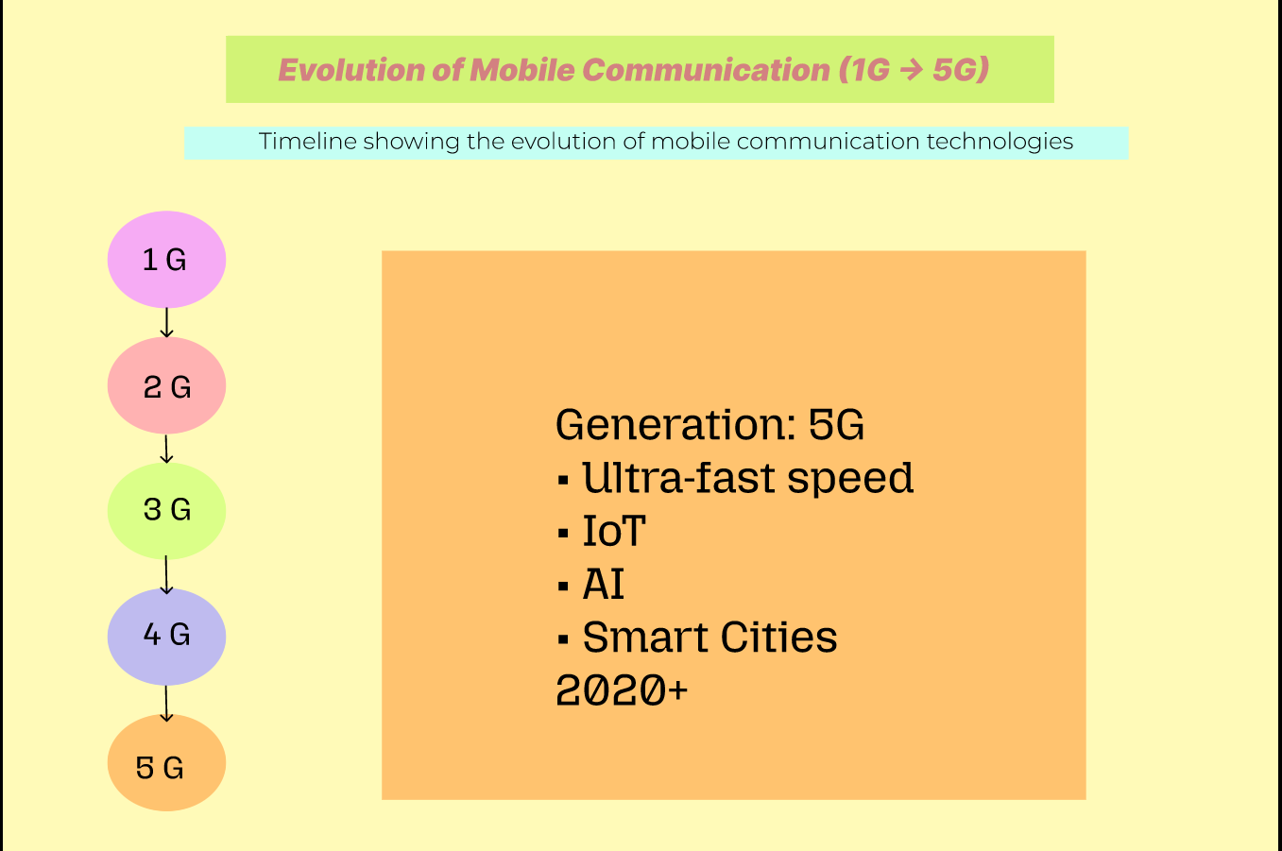
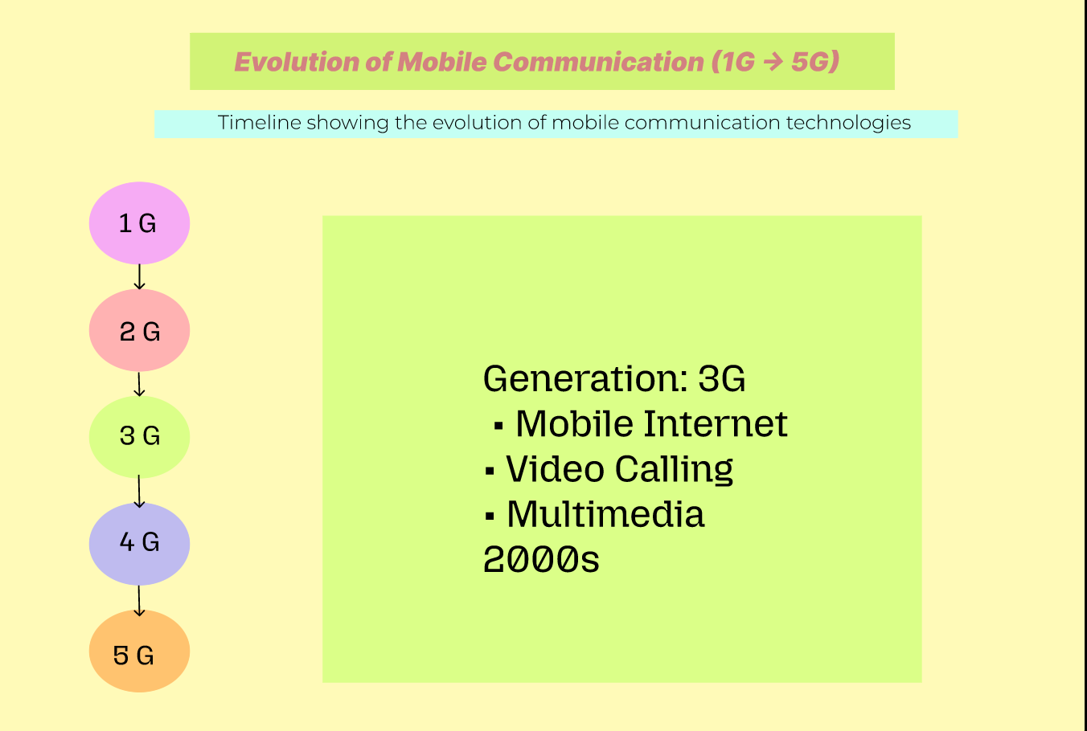

- https://www.figma.com/make/XzIW4rjlNrKCq2hZLqDhAH/Educational-Infographic-Design?code-node-id=0-6&p=f&t=4zGmnNz9DT8VvcsO-0&fullscreen=1

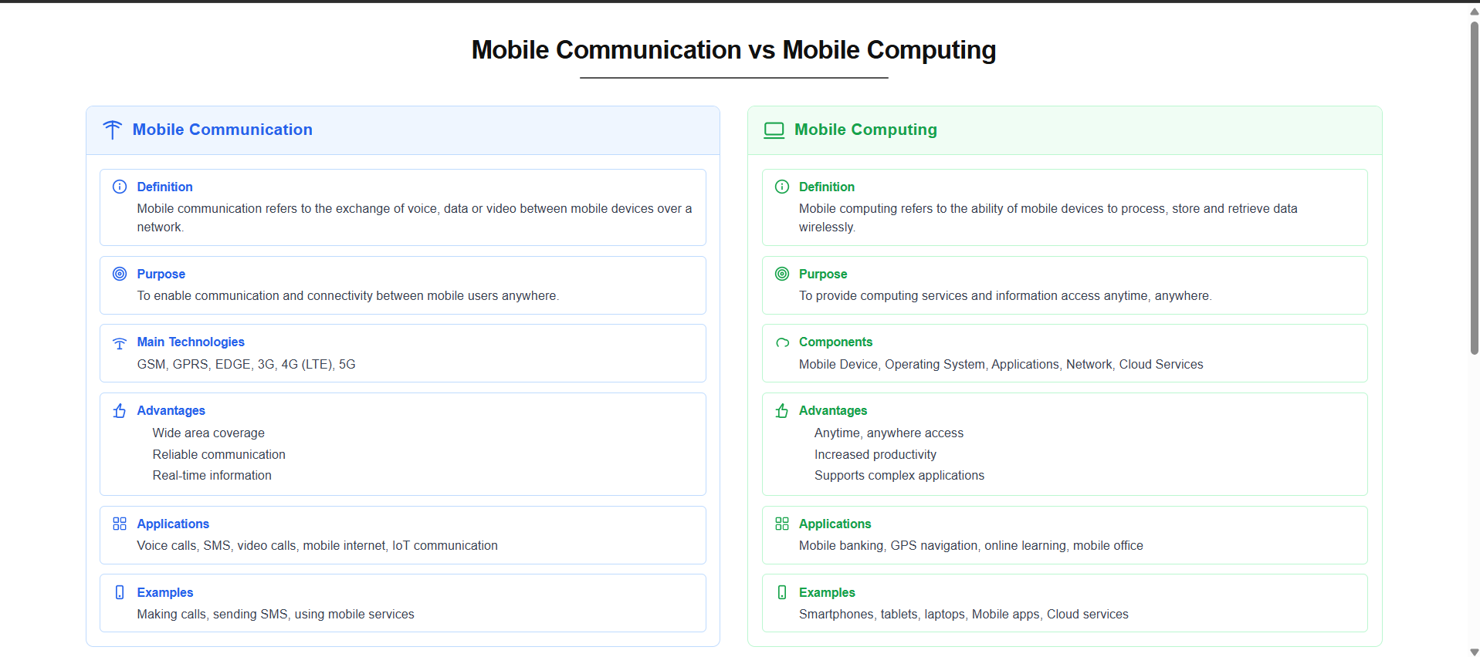

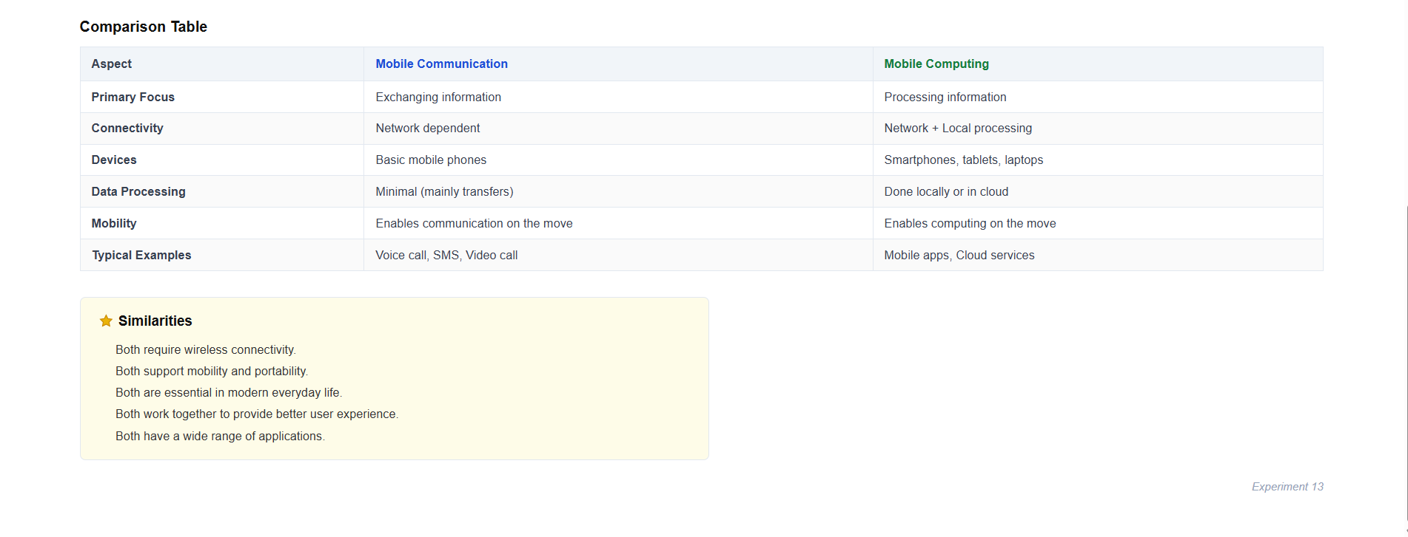

- https://www.figma.com/proto/IeU4qxZmbBN2CcEBXWMlCD/Untitled?node-id=1-2&p=f&t=J09AUx1zujs787wY-0&scaling=min-zoom&content-scaling=fixed&page-id=0%3A1&starting-point-node-id=1%3A2

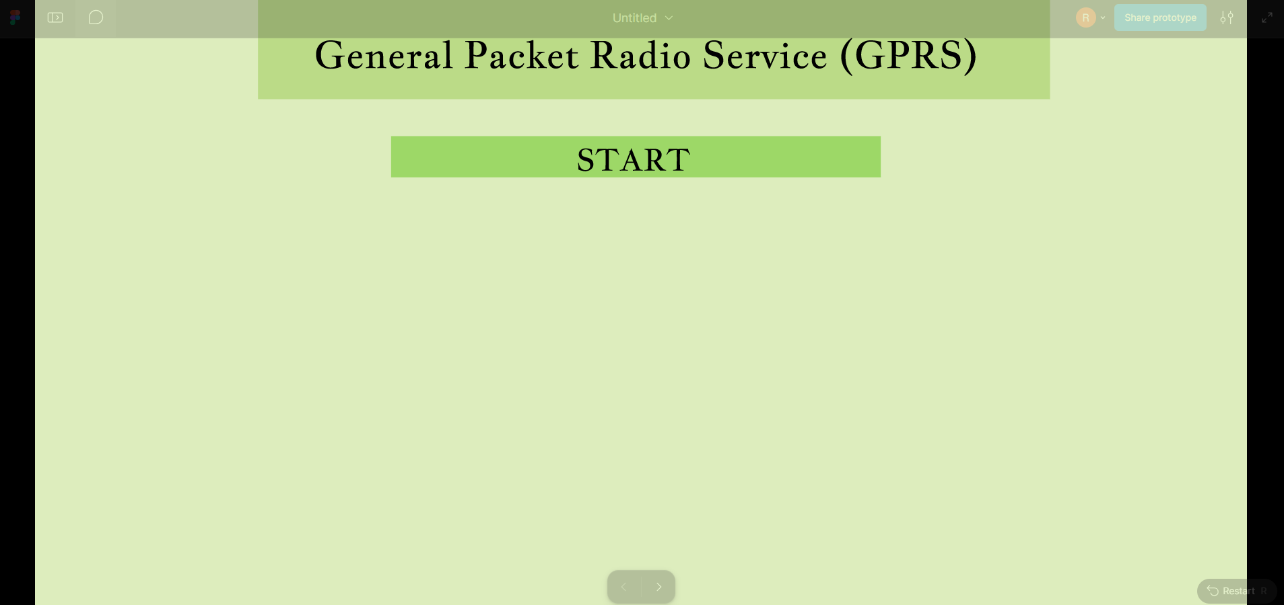
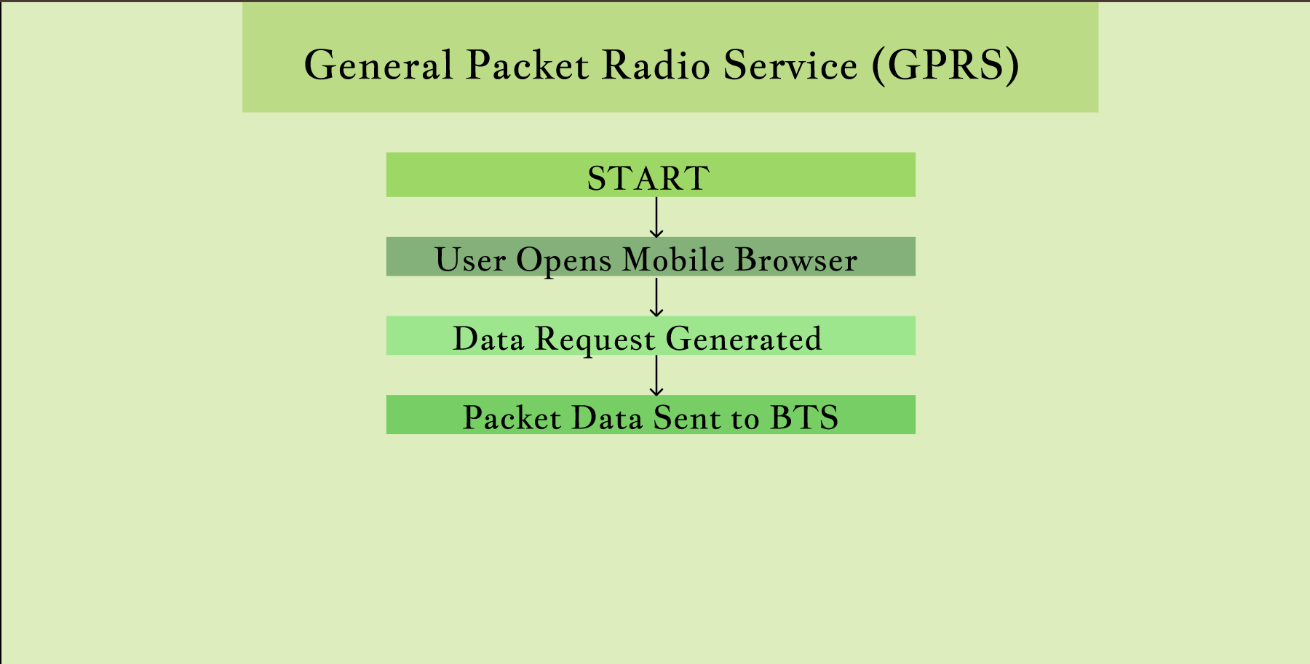
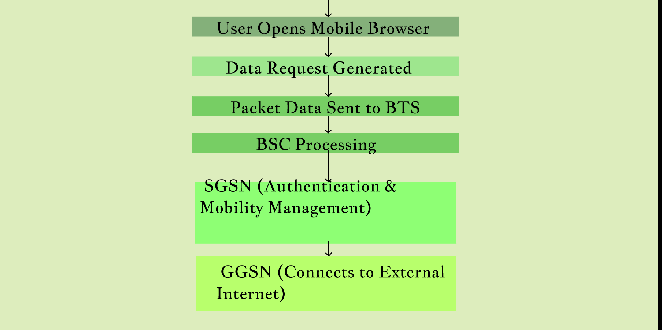

- https://www.figma.com/make/7Q0DcMvQtsaueJ3JDtTsga/Beginner-friendly-design-creation?t=N7BRQbKxxasSqHYm-1

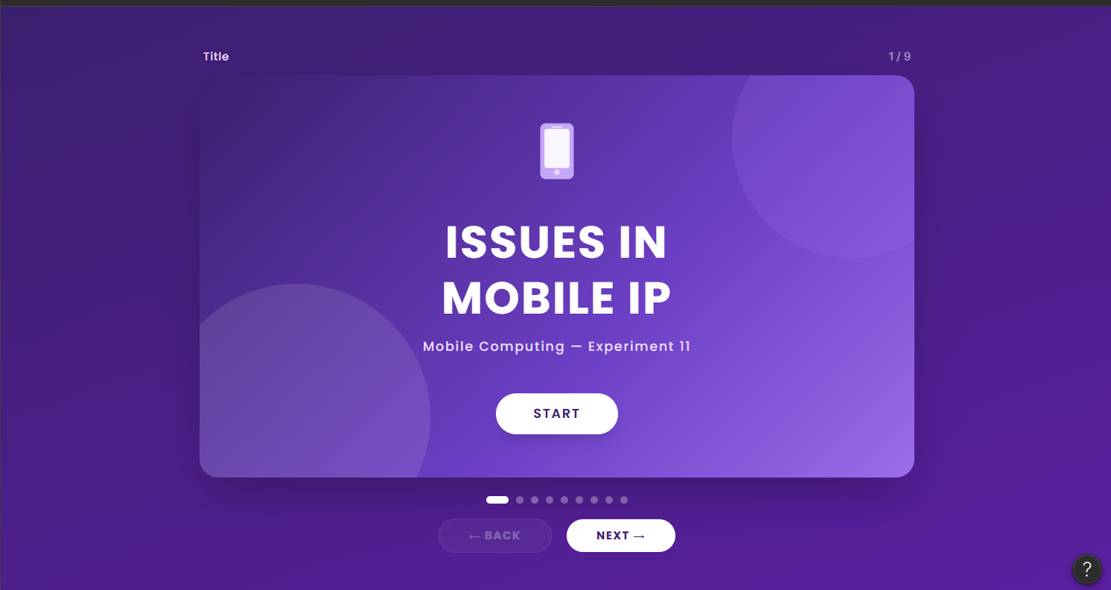
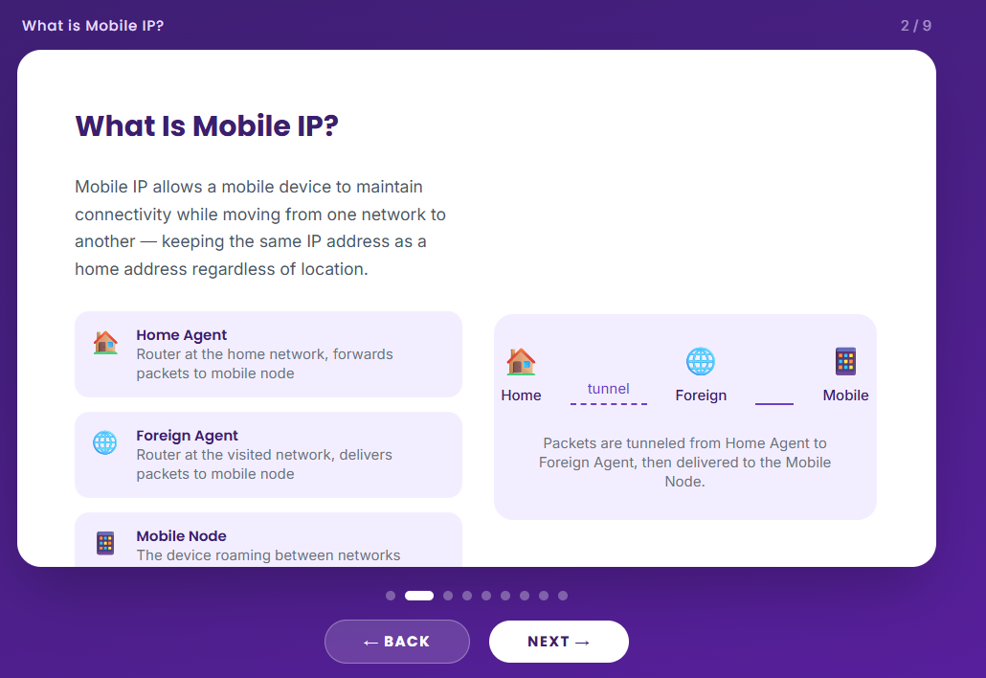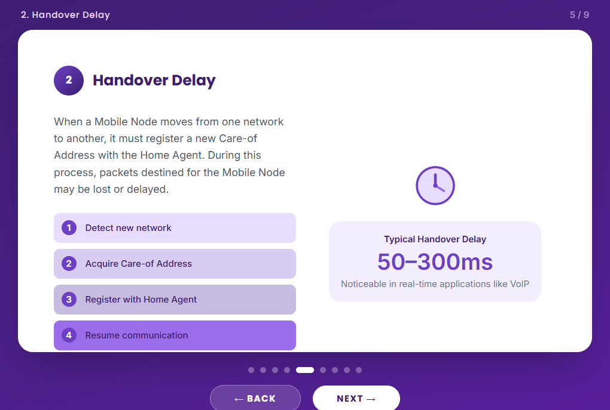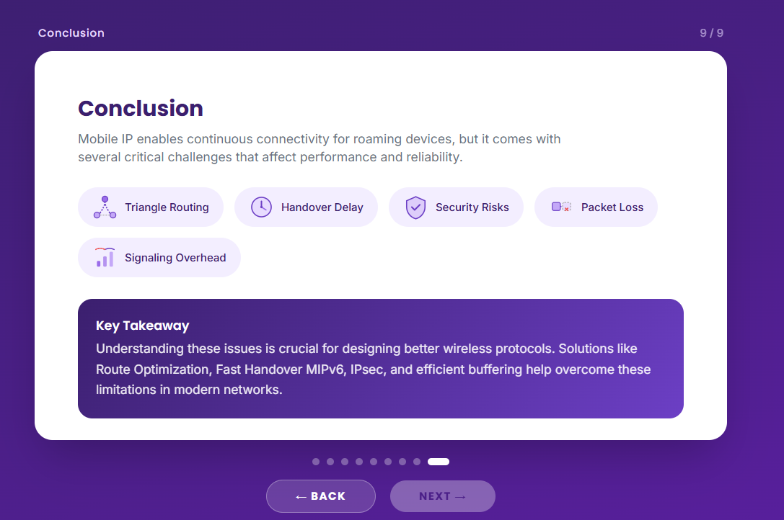

- https://www.figma.com/design/xfeolWY6sUNxXiSLlKBdn8/Untitled?node-id=1-7&t=N7BRQbKxxasSqHYm-1

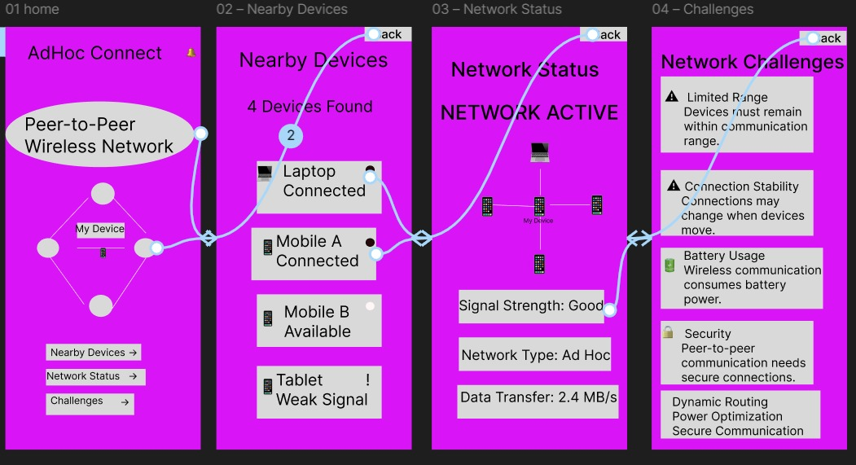

30. https://www.figma.com/proto/4PpklmxLHb4cDzUSyjNzyl/Music-App-UI-Kit--Community-?node-id=40-4801&p=f&t=LmDVGeiRmOCvS3WW-0&scaling=scale-down&content-scaling=fixed&page-id=0%3A1&starting-point-node-id=40%3A4801

